SMS-Controlled Smart Noticeboard

A PROJECT REPORT
CSA1343 THEORY OF COMPUTATION WITH PUSH DOWN AUTOMATA
Submitted to
SAVEETHA INSTITUTE OF MEDICAL AND TECHNICAL SCIENCES
In partial fulfilment of the award of the degree of
BACHELOR OF ENGINEERING IN COMPUTER SCIENCE

By
- YAMINI [192111343]
- KEERTHANANJANI [192211832]
Supervisor
Dr. K. Vijaya Bhaskar



SAVEETHA SCHOOL OF ENGINEERING
APRIL-2024
Abstract:
Aim: In this project, we suggest utilising SMS (Short Message Service) technology to manage noticeboards. Using short text messages, the technology allows users to remotely update and display messages on a noticeboard. By enabling remote access and control, this technology improves the effectiveness and adaptability of traditional noticeboard management. The project include developing the noticeboard system's hardware and software components as well as testing and evaluating them to determine their usability and functionality. Materials and methods:Hardware: The LED display panel, power supply, GSM module for SMS connection, and micro controller (such as Arduino) make up the smart noticeboard system. Software Development: The micro controller is programmed to interpret commands from SMS messages, operate the LED display, and handle message storage. Integration: Software modules are functionally tested and hardware components are constructed and integrated. User Interface: Users can transmit commands to the noticeboard via an easy-to-use SMS interface. Results and Discussion:Functionality: SMS commands are successfully received and interpreted by the SMS-Controlled smart noticeboard system, allowing it to update and display messages.
User Experience: The SMS interface is user-friendly and enables prompt and distant message updates. Reliability: There is little error or delay in the system's message transmission and display.Benefits: By allowing remote access and control, the SMS-Controlled system eliminates the need for face-to-face interaction with the noticeboard. It allows for timely updates from any location and improves message management flexibility. Difficulties: Technical difficulties could arise when integrating GSM connectivity with micro-controller programming. Other factors to take into account are optimising power usage and guaranteeing interoperability with various GSM networks. Future Improvements: Multimedia content support, integration with web platforms for message scheduling, and addition of sensors for automated message updates. Conclusion: A viable option for effective and adaptable information distribution is the SMS-Controlled smart noticeboard system. By providing remote access and control through SMS technology, it overcomes the drawbacks of conventional noticeboards. Although there is need for more improvement and optimisation, the system shows promise and is useful in a variety of contexts. This initiative creates opportunities for more study and advancement in the area of intelligent sign age.

INTRODUCTION

Effective communication is critical in all facets of life in the dynamic and fast-paced world of today, whether it be public announcements, business, or education. Historically, noticeboards have been used in a variety of locations, such as offices, public areas, community centres, and schools, to provide information. Conventional noticeboards, on the other hand, frequently have drawbacks including static content, restricted accessibility, and the requirement for physical engagement in order to update messages. The idea of "smart" noticeboards has arisen in response to the demand for more dynamic, effective, and remotely accessible communication solutions. By utilising contemporary technologies, these inventive solutions surpass the limitations of conventional noticeboards, providing improved adaptability, engagement, and ease of information sharing.An example of a technological improvement in smart noticeboards is the use of SMS (Short Message Service) for remote management. Due to its widespread use and accessibility, SMS is a perfect platform for remotely updating and managing noticeboard information. Through the use of SMS, users can update messages on the noticeboard without being physically there or requiring certain equipment by sending commands from their mobile smart phones. In order to enable smooth communication between users and the noticeboard, hardware and software components have been combined to create the SMS-Controlled smart noticeboard system. Typically, it is made up of an LED display panel, an SMS transmission GSM (Global System for Mobile Communications) module, a micro controller unit, and related peripherals.

Operationally speaking, the SMS-Controlled smart noticeboard provides unmatched message management efficiency and convenience. All that users have to do is text the desired message content, coupled with commands like "update," "display," or "delete," to the phone number mentioned on the noticeboard. After processing these commands, the system modifies the message database and instantly shows the pertinent data on the LED display screen. There are several benefits to using this creative noticeboard management strategy over more conventional ones. First of all, it makes remote updates possible from any location with cellphone coverage by doing away with the requirement for physical access to the noticeboard. When instantaneous message dissemination is necessary if the noticeboard is situated in an inaccessible or remote location, this capability is quite helpful.Additionally, the SMS-Controlled system improves message distribution's quickness and flexibility. When necessary, users can swiftly update or modify messages without the delays or logistical difficulties that come with manual interventions. The noticeboard capacity to interact in real-time keeps it current and useful, enabling it to accomplish its intended function of providing the intended audience with crucial information.
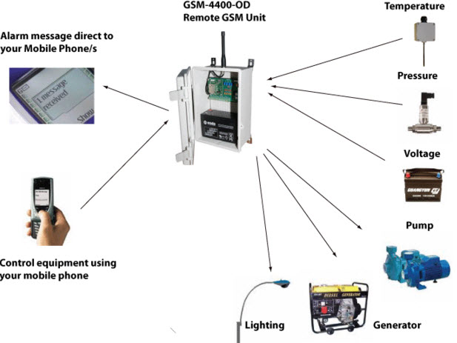

Materials and methods:

Micro controller: Pick a micro controller board that works well for integrating with the LED display panel and GSM module. Arduino boards are widely used because of their enormous community support and adaptability, such as the Arduino U no and Arduino Mega. GSM Module: Select a GSM module with SMS communication capabilities. Popular options are SIM900 and SIM800 modules. Verify that it is compatible with both your micro controller board and the local cell network.LED Display Panel: Select an LED display panel based on the size and viewing distance of your noticeboard. Because of its transparency and adaptability in showing text and graphics, LED matrix and segmented LED displays are frequently utilised.
Power Supply: Make sure the micro controller, GSM module, and LED display panel have enough power. Use a battery pack, wall adapter, or a mix of the two depending on the power needs of your components.

Buying a SIM card that works with the GSM module and cellular network is advised. Make sure there is enough credit on the SIM card and that it is active in order to send and receive SMS texts.Before putting components onto a permanent PCB (Printed Circuit Board), construct and test the circuits using a breadboard or prototyping board. Collect the jumper wires, resistors and capacitors needed to connect the micro controller to the LED display panel and GSM module. This consists of capacitors for voltage, resistors for current limitation, and jumper wires for connectivity. Enclosure/Casing: It is optional to create or purchase an enclosure or casing to house the electronics and shield them from the elements, including moisture and dust.

Hardware Configuration: As directed by the individual pin out diagrams and data sheets for the GSM module and LED display panel, connect the micro controller board to them.Verify that all components have the correct voltage levels and power connections. In order to confirm communication between the micro controller, GSM module, and LED display, test the hardware configuration using simple example scripts. Software Engineering: write the micro controller's firmware or software to:Start up a dialogue with the GSM module. Set up the GSM module so that it can send and receive SMS messages. Recognise and extract message content from incoming SMS commands (such as update, display, and delete). Save and update message data on external storage or non-volatile memory, such as EEPROM. To see the desired messages, operate the LED display panel. Put error-handling and recovery procedures in place to guarantee reliable operation. Test each software module separately and then combine them to create a coherent system.

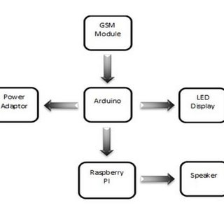

Results and Discussions:

Testing for functionality:Successfully receiving SMS commands, the SMS-Controlled smart noticeboard system decodes them to update and display messages on the LED display panel.Tests reveal that basic features including message updates, displays, and removals perform as anticipated.The notice board's information is updated in real-time and incoming SMS messages are processed reliably by the system.Assessment of User Experience:Sending commands and updating messages on the noticeboard is a simple and intuitive experience for users of the SMS interface.Users' feedback shows that they are happy with how convenient remote message management is, particularly when it is difficult or impossible to physically visit the noticeboard.All things considered, the system improves user experience by offering a smooth and effective way to handle noticeboards.

Benefits of the System Controlled by SMS:Compared to conventional noticeboard management techniques, the SMS-Controlled smart noticeboard has a number of benefits, such as:
Remote accessibility: Users do not need to be physically present to update messages; they can do so from any location with cellular coverage.Real-time updates: Information can be shared promptly by allowing messages to be updated instantaneously and shown on the noticeboard.Easy to use: A broad spectrum of users may easily utilise the straightforward SMS interface, as it doesn't require any specialised expertise.Flexibility: The system enables dynamic content updates based on changing needs, allowing for rapid and simple message modifications.

Conclusions:

To sum up, the SMS-Controlled Smart Noticeboard project has proven that using SMS technology for remote noticeboard management is both feasible and useful. Although there is room for improvement, the system's effectiveness, usability, and dependability make it an invaluable tool for promoting efficient communication and information exchange. These kinds of smart noticeboard solutions are well-positioned to address the changing communication needs of various locations and communities as technology advances.

References:

- Kamdari, A. Malhotra, and P. Mahadik, “Display message on notice board using gsm,” Advance
in Electronic and Electric Engineering, vol. 3, no. 7, pp. 827–832, 2013.
- P. U. Ketkar, K. P. Tayade, A. P. Kulkarni, and R. M. Tugnayat, “Gsm mobile phone based ledscrolling message display system,” International Journal of Scientiﬁc Engineering and Technology,vol. 2, no. 3, pp. 149–155, 2013.
- J. Komal, S. Sana, S. Swapnali, B. Jasmin, and R. N. Mahind, “Android based college notiﬁcationsystem,” International Research Journal of Engineering and Technology (IRJET), vol. 3, no. 3,pp. 1768–1770, 2016.
- P. Kumar, V. Bhrdwaj, K. Pal, N. S. Rathor, and A. Mishra, “Gsm based e-notice board: Wirelesscommunication,” International Journal of Soft Computing and Engineering, vol. 2, no. 3, pp. 601–605, 2012.
- P. S. Kumar, V. Priyanka, L. Surekha, and Y. H. Reddy, “Gsm based wireless electronic noticeboard display through arm7 and led,” International Journal of Advanced Technology and InnovativeResearch, vol. 8, no. 5, pp. 0864–0868, 2016.
- A. Meenachi, S. Kowsalya, and P. P. Kumar, “Wireless e-notice board using wi-ﬁ and bluetooth technology,” Journal of Network Communications and Emerging Technologies (JNCET), vol. 6,no. 4, pp. 14–20, 2016.
- P. Mishra, P. Singh, and S. Gupta, “Sms based wireless notice board display using gsm mobile,”International Journal of Advance Research in Science and Engineering, vol. 2, no. 10, pp. 20–24,2013.
- A. Mujumdar, V. Niranjane, and D. Sagne, “Scrolling led display using wireless transmission,”International Journal of Engineering Development and Research, vol. 2, no. 1, pp. 475–478, 2014.
- K. G. Ramchandra and J. Rohit, “Wireless digital notice board using gsm technology,” International Research Journal of Engineering and Technology (IRJET), vol. 2, no. 9, pp. 57–59, 2015.
- B. Saini, R. Devi, S. Dhankhar, S. Hague, and J.Kauai“Smart led display boards,” International Journal of Electronic and Electrical Engineering, vol. 7, no. 10, pp. 1057–1067, 2014

